ICSTATION 4X4X4 guide light cube suite

NOTE: changed ‘w e l d’ to ‘soldering’, etc.

一The component List

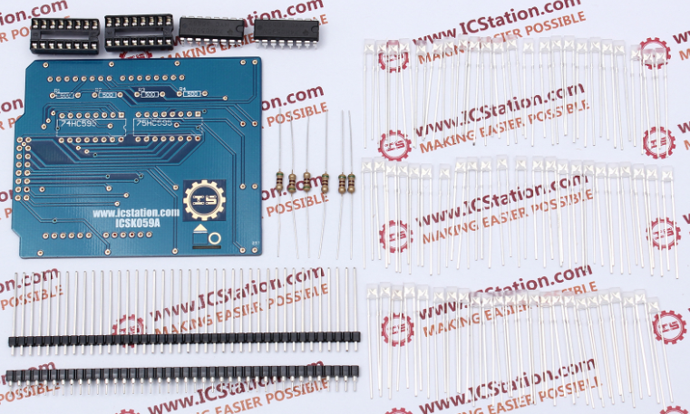

1.PCB

2. Two of 16P IC seat

3. Two of 74HC595

4. six of 500R resistance

5. A 40 p fillet mother

6. A 40 p row needles

7. Seventy of 5 mm flat LED

二.Make the rounded row needles  
Rounded corners from the suite separate row needles with diagonal cutting pliers and remove the black plastic, as shown in figure

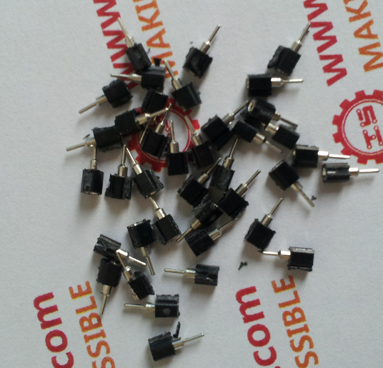 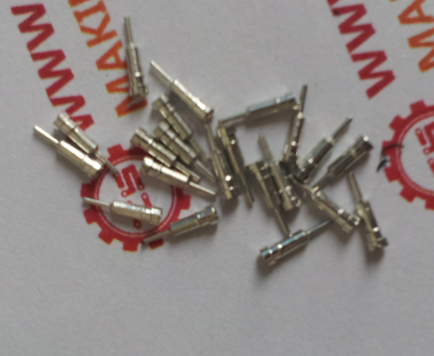

Will be rounded corners front row needles soldered to the PCB, as shown in figure

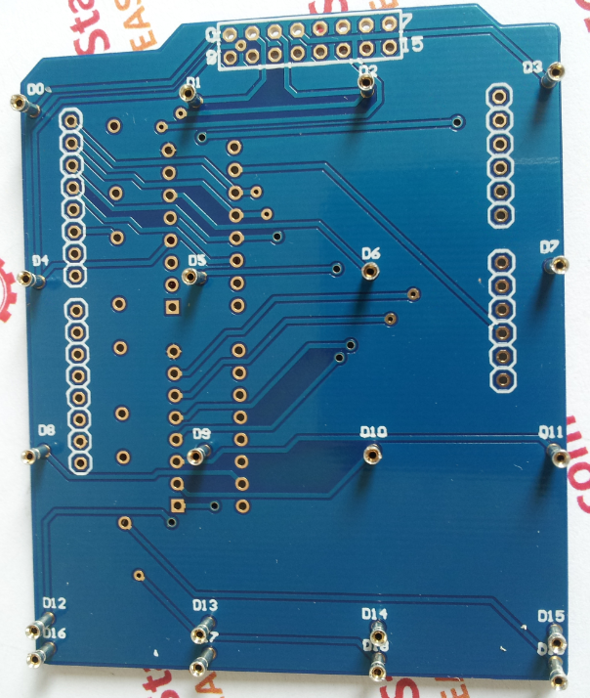

Resistance soldering on the back of the four euro 500, as shown in figure

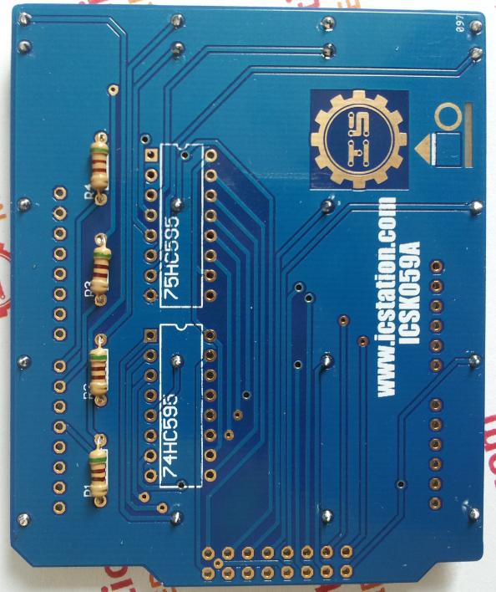

Soldering two 16 p IC  
Note: IC soldering has direction, IC on the gap of the corresponding to the direction of the gap on the PCB, as shown in figure

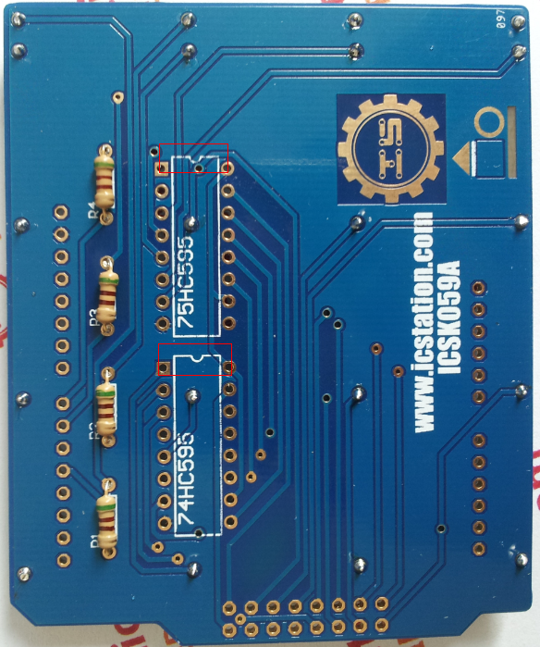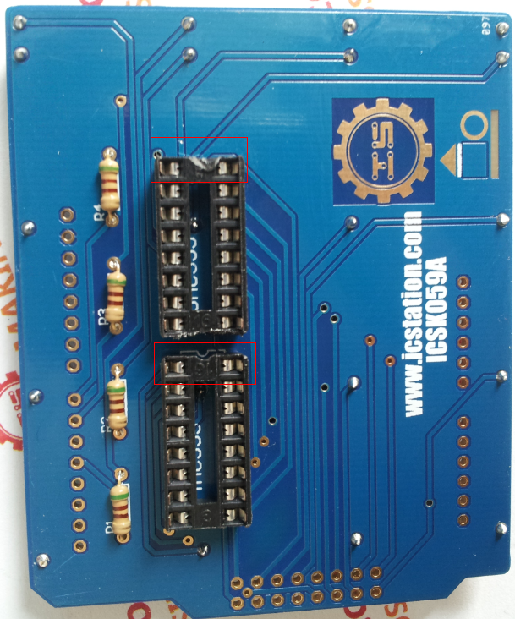

Production soldering frame, as shown in figure

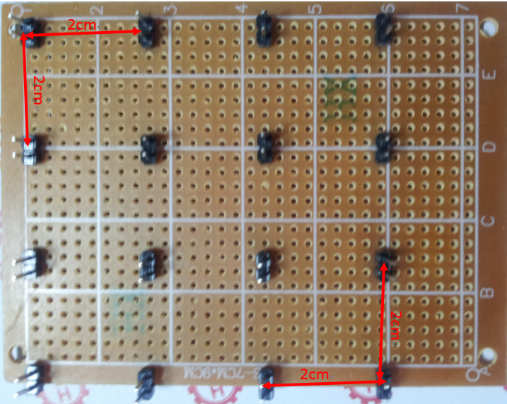

Will LED the anode (longer pins) next to the LED the cathode (shorter pin) next, rotating anode, LED to 90 degrees.As shown in figure

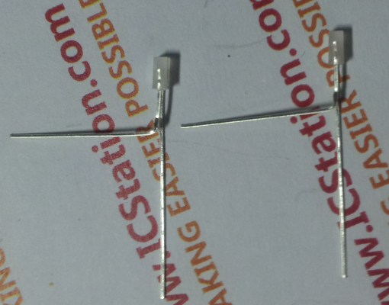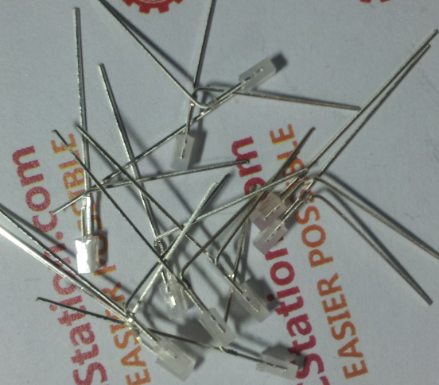

Use of soldering, soldering 4 surface LED four LED (4 x4 LED), as shown figure

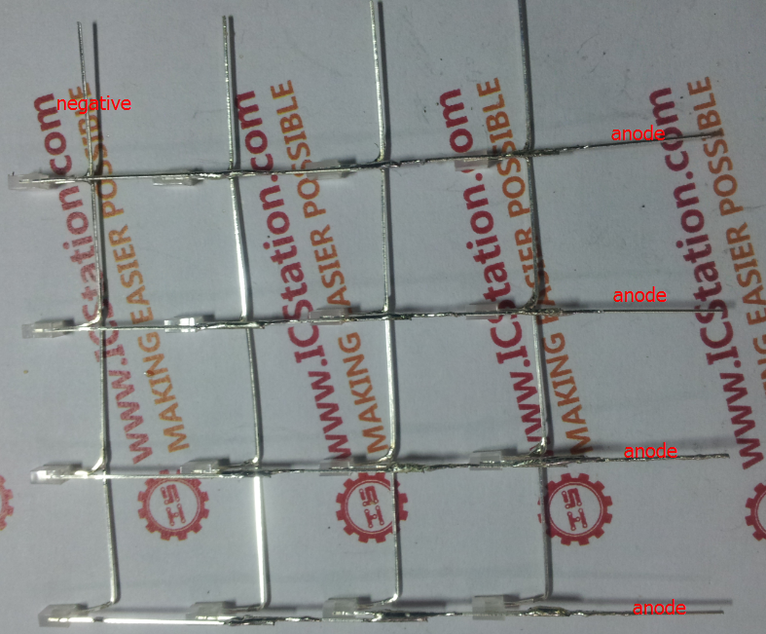

Put the LED of the anode D0 ~ D15 round needle, each layer of LED anode with 2 cm row needle soldered together, as shown in figure

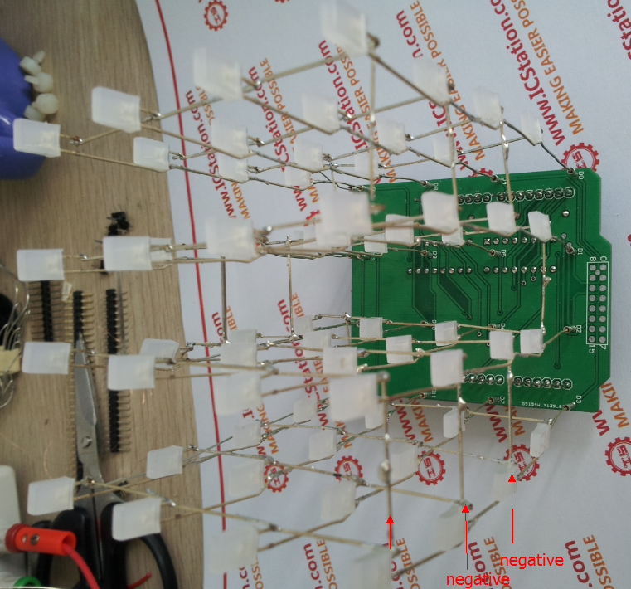

The LED anode with each layer of enameled wire, connect D16 ~ D19, as shown in figure 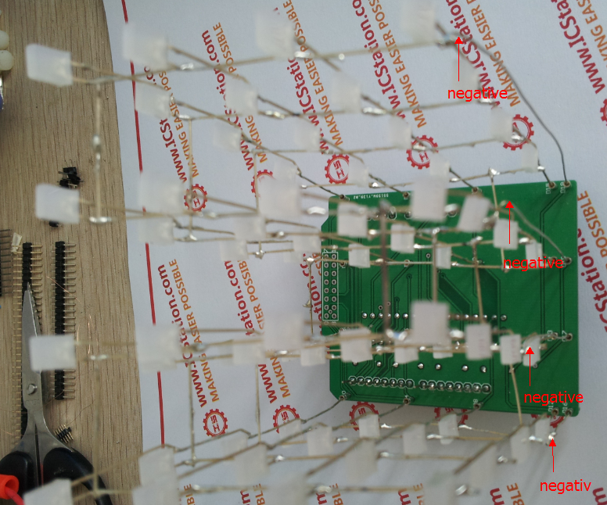

The overall effect as shown in figure